1. Previously Insured v Annual_Premium

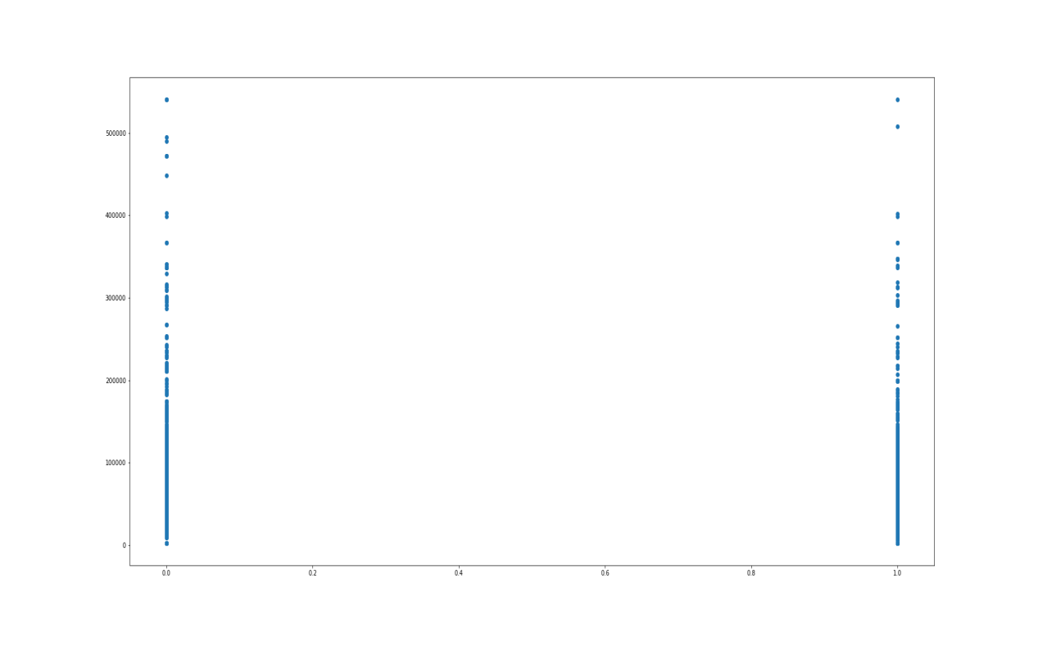

Number of people with large premium and who did not have previous insurance are more compared to the ones with previous insurance.

1. Vintage v A_P

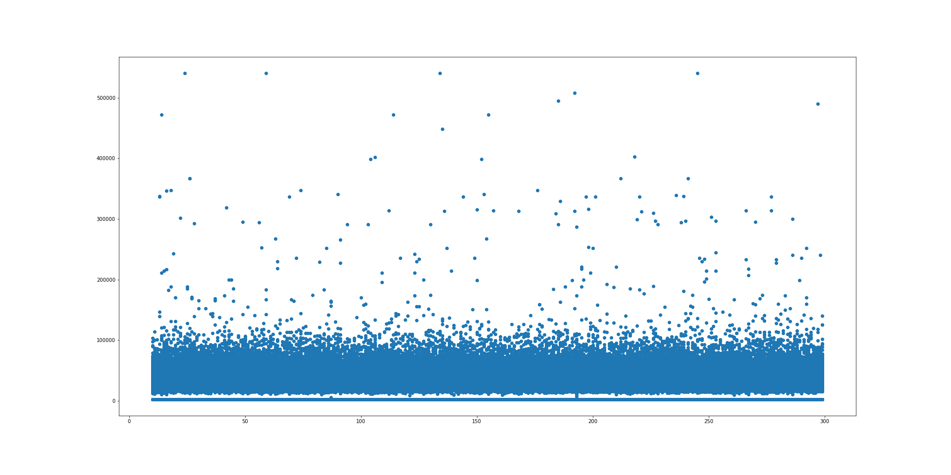

Maximum of population is below 100,000 A_P. Also vintage doesn’t seem to have a big impact.

1. Data set is skewed 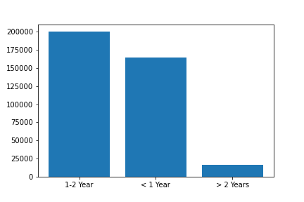

X = Vehicle age

Y = Annual Premium